HEPATITIS “B” & “C” CASE HISTORY FILE NO. - ………………….

Name of Patient | Age | Date
Ashok Singh | 52Y

Symptoms | Alcoholic Hepatitis
Ref. Doctor’s Name | V.R. Ashu Grover
Diagnosis | Liver Cirrhosis & Jaundice

Positive Hepatitis “B” & “C” | Confirmed | Dated
Hepatitis | “B”
Treatment Started By Dated – 25-09-2012
VAIDHRANI – Mrs. Ashu Grover (Grow Liv D.S. Syrup Treatment)
Pathological Reports (Receding Figures)
Date | Total Serum Billirubin | Direct Serum Billirubin | S.G.O.T. | S.G.P.T. | S.ALK Phosphatase.
 | Saved from Liver Transplant Stage & Cured by Herbal Treatment Only. In Reference – V.R. Ashu Grover

Negative Report Dated –

Full Treatment –Grow Liv – V.K. , DS, Kabz, Evergreen

Gratitude/Reference Letter Dated - 25-09-2012

PRIYAL’S GROW LIV HERBAL SYRUP .
Supporting Case Files of V.R. Ashu Grover, Bhopal

Liver Transplant Suggested

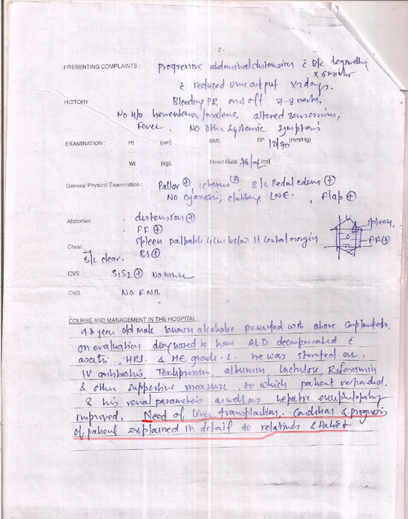

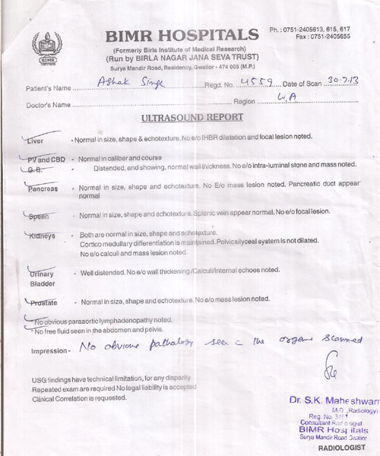

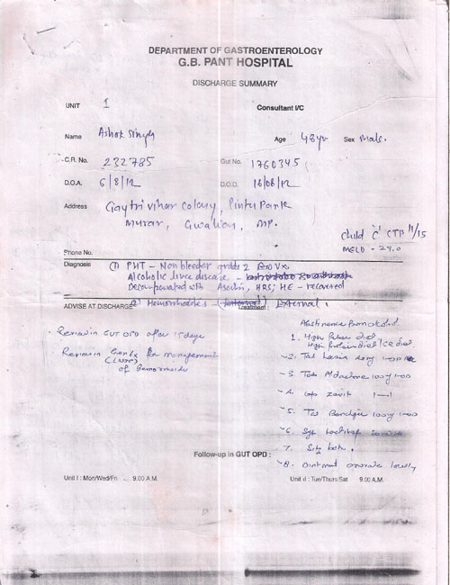

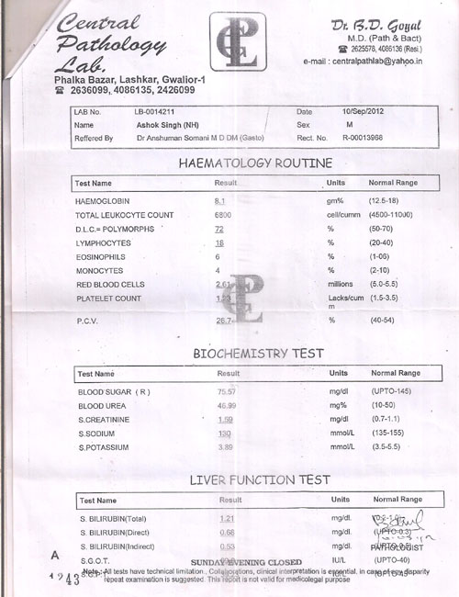

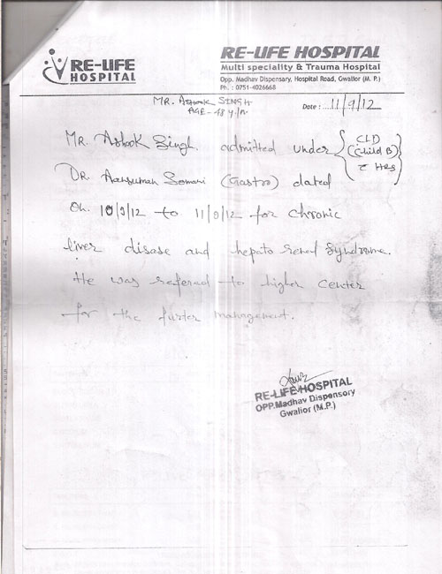

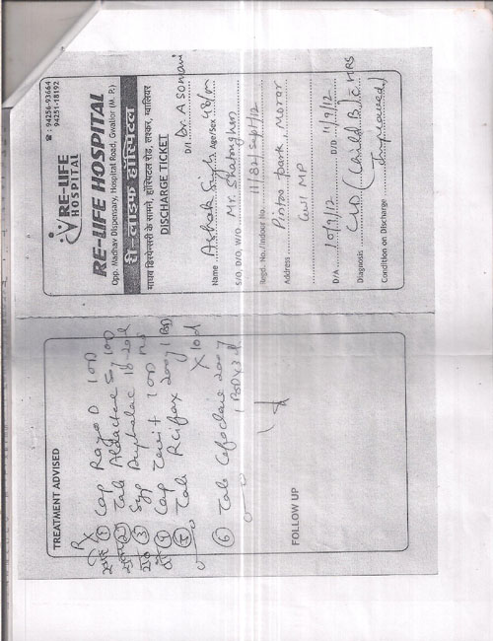

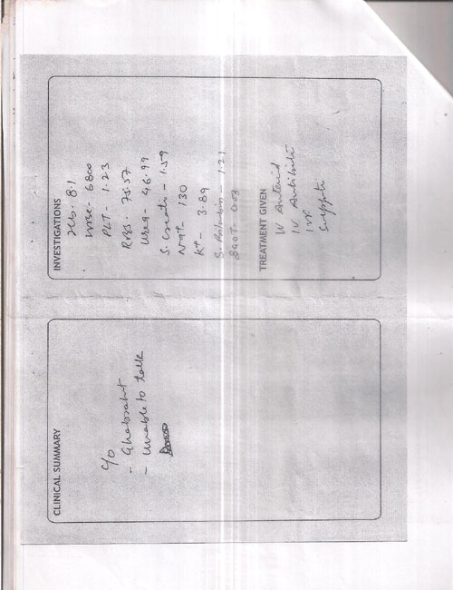

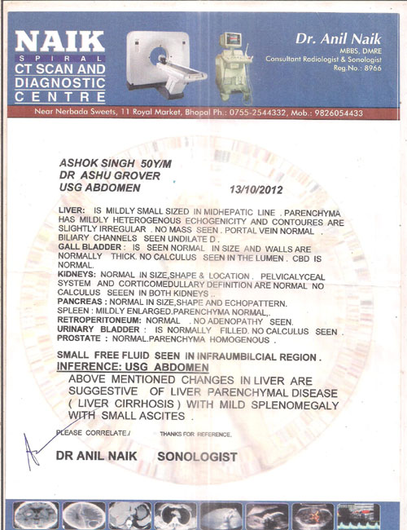

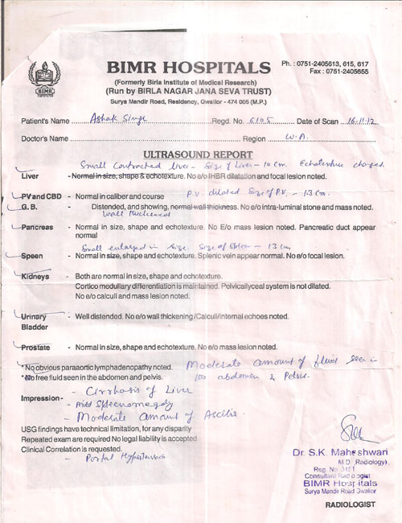

Transplant Package from ILBS Delhi



